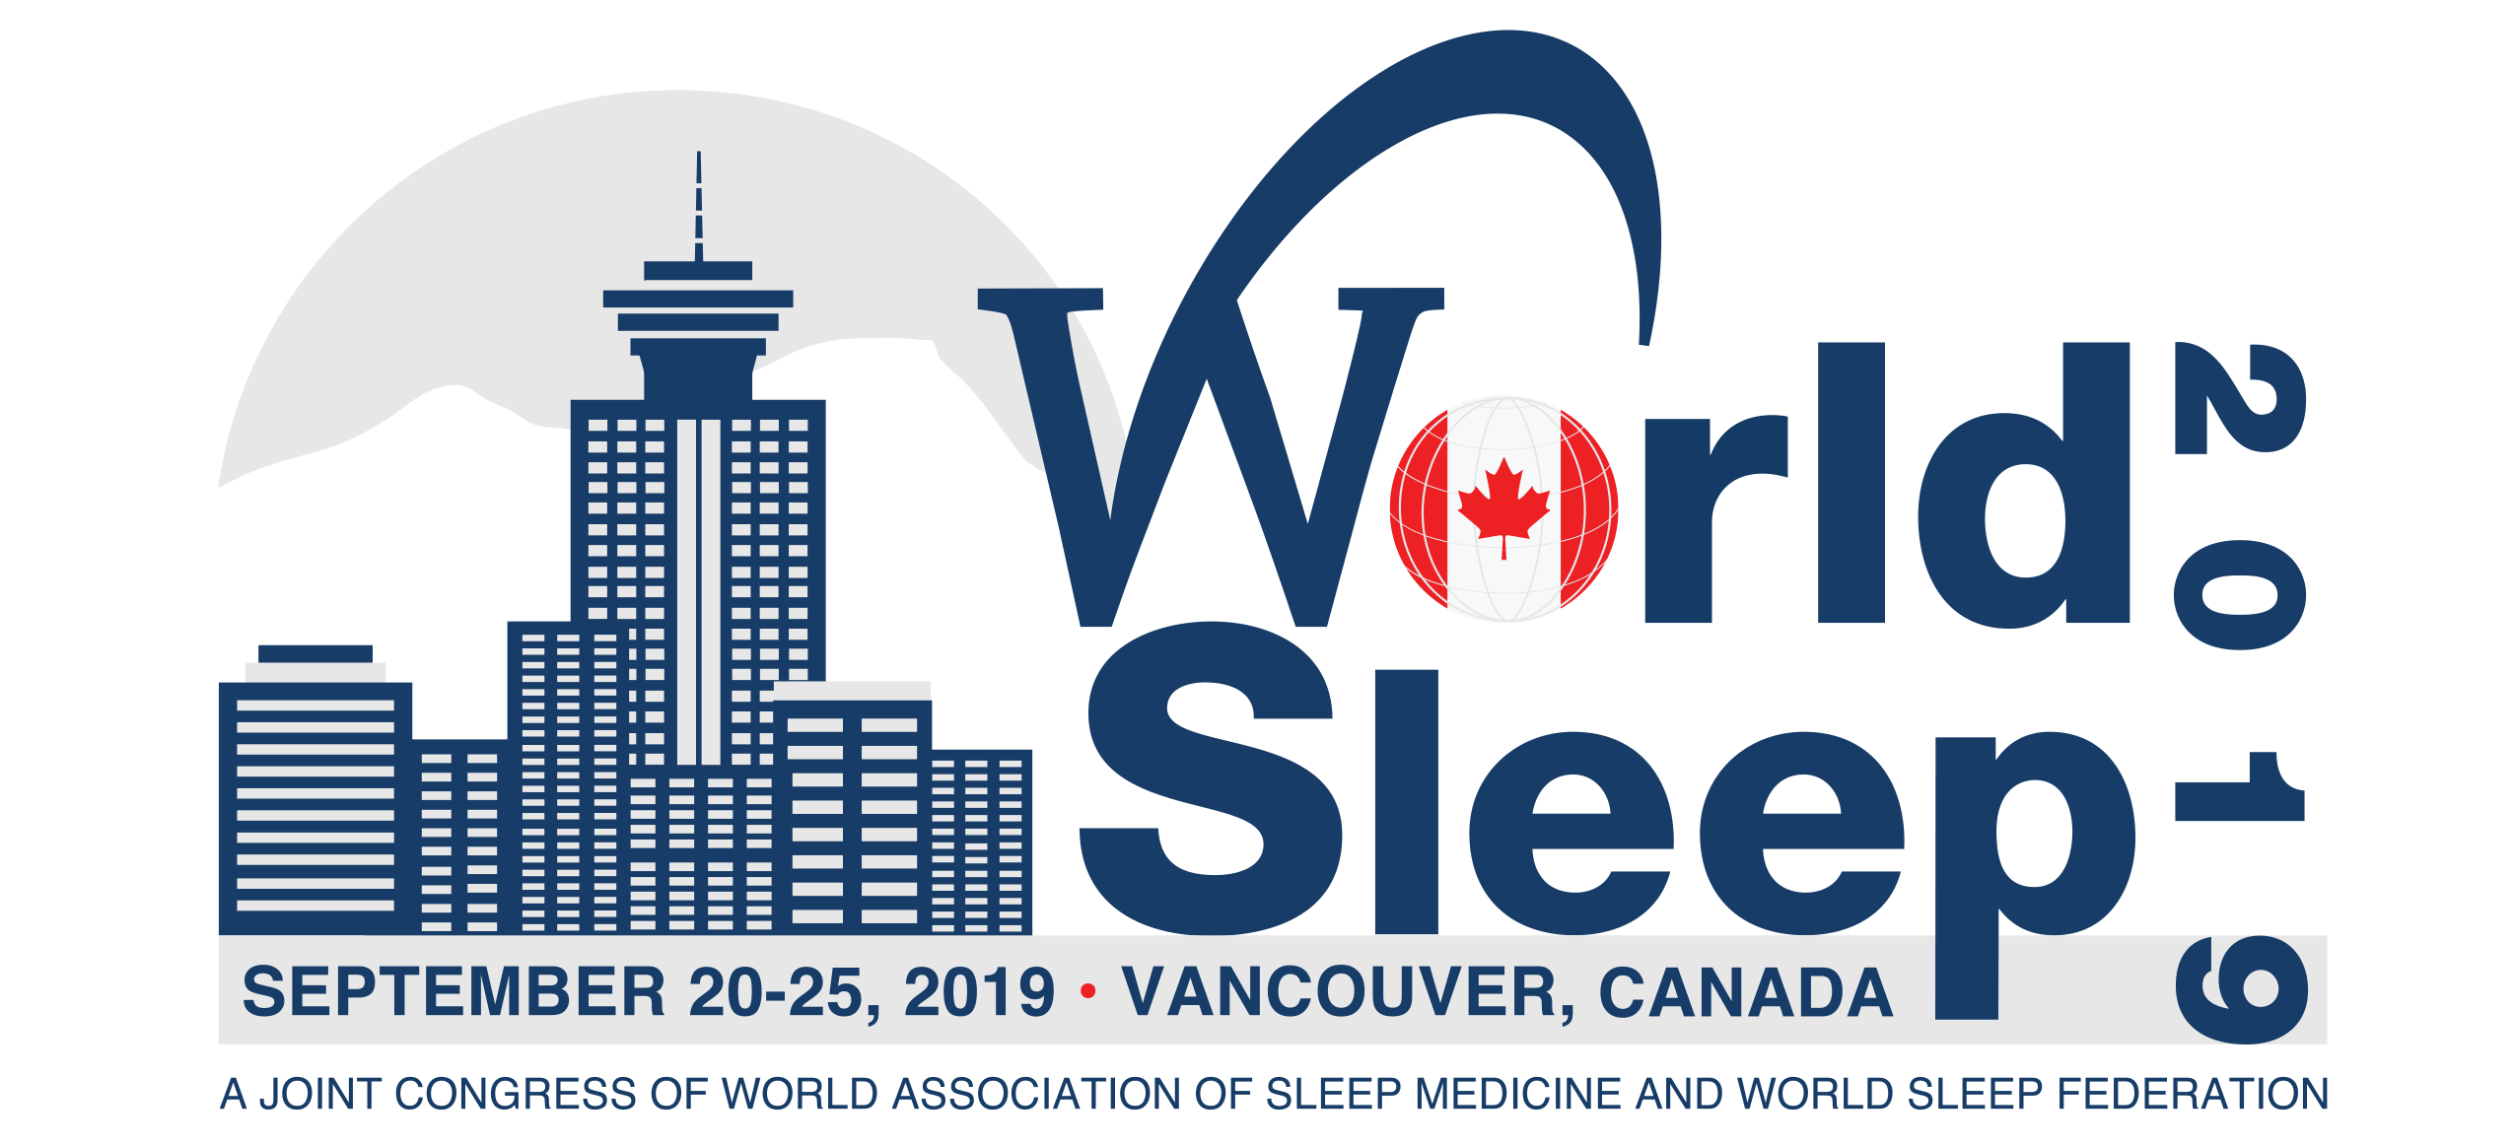
The Benefits of Attending World Sleep 2019
To:
From:
Re: World Sleep 2019: Advancing Sleep Health Worldwide

Dear [Insert name],
I’m writing to ask for approval to attend World Sleep 2019 from September 21-25, 2019 at the Vancouver Convention Centre in Canada. After carefully reviewing the congress program, agenda, sessions, networking opportunities and exhibit hall, I am confident this is a great opportunity to help us recognize our potential through the latest innovative technologies and trends driving sleep medicine and research industry–along with tailored solutions for challenges facing the industry.
In addition to 278+ hours of scientific content within the in-depth symposia sessions, and a number of powerful networking events, the sleep medicine and research congress offers the chance to speak with peers to share the latest in research, relevant technological advances and best practices. This is a perfect forum to discover what the trends in sleep and research are across the globe. At the last congress, sleep experts from 76 countries attended. In particular, I’d like to use World Sleep 2019 to focus on finding solutions to benefit these areas:
- [add project or initiative]
- [add project or initiative]
- [add project or initiative]

The congress will focus on several key areas in sleep including: Aging and Developmental Issues, Basic Research, Behavior, Cognition and Dreaming, Chronobiology/Circadian Disorders, Excessive Daytime Sleepiness, Hypersomnia, Insomnia, Memory, Movement Disorders, Narcolepsy, Neurological Sleep Disorders Affecting Sleep, Neural Plasticity, Parasomnia, Pharmacology, Psychiatric Disorders Affecting Sleep/Wake, Restless Legs Syndrome (RLS), REM Behavior Disorders and Sleep Breathing Disorders. World Sleep 2019 is the only global scientific congress devoted to sleep.
After I return from World Sleep 2019, I will submit a post-congress summary report. In it I will identify major takeaways, tips, and a set of recommendations to move forward on.

An approximate breakdown of costs:
Registration Fee: World Sleep 2019 $xxx [Find your rate online. Early rates end April 30, 2019.]
Airfare/Car/Parking $xxx
Transportation (between airport and hotel): $xx
Hotel: $xxx [Hotel rates are listed in Canadian dollar. Find hotel rates.]
Meals: $xxx
Total: $X,XXX

The earlier I register, the less expensive it will be. You can learn more about the conference at www.worldsleepcongress.com.
Thank you for considering this request. I look forward to your reply.
Regards,

