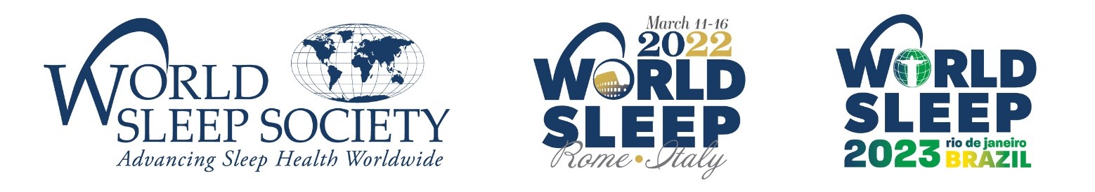

FOR IMMEDIATE RELEASE

World Sleep Society
obryan@worldsleepsociety.org
+1.507.316.0084
worldsleepcongress.com

WORLD SLEEP 2021 CONGRESS ON SLEEP MEDICINE
MOVED TO 2022 AMID PANDEMIC

ROCHESTER, MN –September 18, 2020— World Sleep Society leadership has made the decision to hold World Sleep 2022 from Friday, March 11 through Wednesday, March 16, 2022 in Rome, Italy with Italian Association of Sleep Medicine as the host society. The Italian Association of Sleep Medicine had already been selected to host the 2023 World Sleep congress. However, due to the central location of Italy, the decision has been made to switch the locations of the next two meetings, postponing the congress in Brazil until 2023.

On the decision to switch host cities and postpone the congress until 2022, World Sleep Society Executive Director, Allan O’Bryan, explains, “We anticipate travel in 2021 will be limited—even in the event of a COVID-19 vaccine, due to budget and post-COVID19 institutional travel policies. Therefore, we decided to postpone the 2021 congress for six months to March 2022, to allow more time for economic recovery and safe travel. Additionally, a switch from Brazil to Italy will allow our members to attend World Sleep at a more easily accessible location.”

The World Sleep congress will still take place in September 2023 as planned, with the Brazilian Sleep Society as its host. Dr. Andrea Bacelar, President of the Brazilian Sleep Society, states, “On behalf of the Brazilian Sleep Society, it is my privilege to invite you to visit our wonderful city, a Cidade Maravilhosa, in 2023.” Dr. Giuseppe Plazzi, President of the Italian Association of Sleep Medicine adds, “We are pleased to accommodate this change and look forward to welcoming you all to the historic city of Rome, Italy for World Sleep 2022.”

The goal is to showcase both of these national societies with an in-person meeting and the greatest attendance by a global sleep medicine and research audience. President of World Sleep Society, Birgit Högl, MD adds, “We are grateful to both the Brazilian and Italian societies for their flexibility and commitment to providing an exceptional scientific program.”

World Sleep 2022 will offer a worldwide forum inviting sleep professionals to advance current medical and scientific thinking, discover ways to improve sleep health and encourage the prevention and treatment of sleep disorders. Participants are encouraged to submit science for this highly ranked congress. The Sleep Society will begin accepting proposals for scientific symposia and abstract submissions in March 2021.

Important dates for World Sleep 2022 are as follows:
Symposia submission: March 1, 2021-June 30, 2021
Abstract submission: begins June 1, 2021; abstract early deadline: July 31, 2021; Oral and Young or New Investigator deadline: November 30, 2021; Poster deadline: January 15, 2022
Registration opens: February 1, 2021

Save the dates to attend the World Sleep congresses on March 11-16, 2022 (Rome) and in September 2023 (Rio de Janeiro). Find more information on worldsleepcongress.com.

###

About World Sleep Society
World Sleep 2022 and 2023 are being organized by World Sleep Society, an international association whose mission is to advance sleep health worldwide. World Sleep Society hosts the biennial scientific congress on sleep medicine with the aim to globally connect sleep professionals and researchers to advance current knowledge on sleep medicine and research. Follow the excitement on Twitter @_WorldSleep and facebook.com/WASMF.

About Brazilian Sleep Society
Brazilian Sleep Society is a multidisciplinary institution whose missions are the promotion of sleep qualification for health professionals, dissemination of scientific knowledge, and increase the sleep awareness of the general population (absono.com.br).

About the Italian Association of Sleep Medicine (AIMS)
AIMS is a multidisciplinary professional scientific society devoted to promoting awareness, scientific research and clinical training for the knowledge of sleep and its disorders diagnosis and treatment (sonnomed.it).

